**CH5120: Project 1B Report**

**S Tarun Prasad – ME17B114**

**PART 1 : Unconstrained Controller Design:**

* Weights: Q=diag([1,1]) R= diag([1,1])

Code:

%Setting up the model

G11=tf(1.7,[60.48 15.6 1]);

G12=tf(.5,[19.36 7.04 1]);

G21=tf(.3,[10.89 4.62 1]);

G22=tf(1,[36 12 1]);

G=[G11 G12;G21 G22];

model=ss(G);

%Naming and defining the different inputs, outputs and states

model.InputName = {'u1','u2'};

model.OutputName = {'y1','y2'};

model.StateName = {'x1','x2','x3','x4','x5','x6','x7','x8'};

model.InputGroup.MV = 2;

model.OutputGroup.MO = 2;

old_status = mpcverbosity('off');

%Setting up parameters of mpc

Ts=2;

p=12;

m=4;

%Setting up Weights

W=struct('MVRate',[1 1],'OV',[1 1]);

%Setting up the MPC

MPCobj=mpc(model,Ts,p,m,W);

T = 25;

sp = [.4,-.4];

%Running the MPC

sim(MPCobj,T,sp)

* Output:

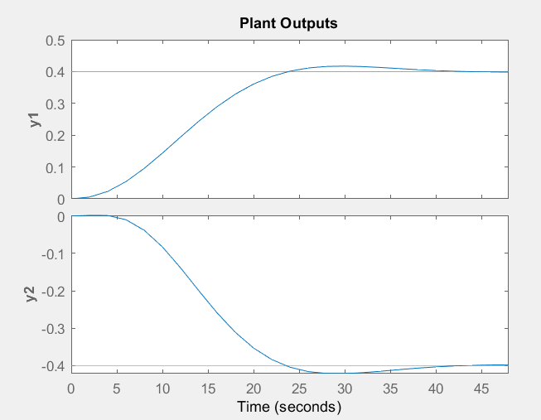

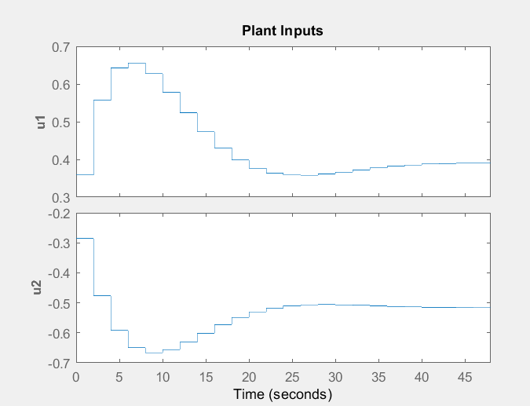

**PART 2: Effect of Constraints:**

* Weights: Q=diag([1,1]) R= diag([1,1])
* Constraints: −0.5 ≤ u ≤0 .5, |Δu| ≤ 0.05

Code:

%Setting up the model

G11=tf(1.7,[60.48 15.6 1]);

G12=tf(.5,[19.36 7.04 1]);

G21=tf(.3,[10.89 4.62 1]);

G22=tf(1,[36 12 1]);

G=[G11 G12;G21 G22];

model=ss(G);

%Naming and defining the different inputs, outputs and states

model.InputName = {'u1','u2'};

model.OutputName = {'y1','y2'};

model.StateName = {'x1','x2','x3','x4','x5','x6','x7','x8'};

model.InputGroup.MV = 2;

model.OutputGroup.MO = 2;

old_status = mpcverbosity('off');

%Setting up parameters of mpc

Ts=2;

p=12;

m=4;

%Setting up Constraints

MV=struct('Min',-.5,'Max',.5,'RateMin',-.05,'RateMax',.05);

%Setting up Weights

W=struct('MVRate',[1 1],'OV',[1 1]);

%Setting up the MPC

MPCobj=mpc(model,Ts,p,m,W,MV);

T = 25;

sp = [.4,-.4];

%Running the MPC

sim(MPCobj,T,sp)

* Output:

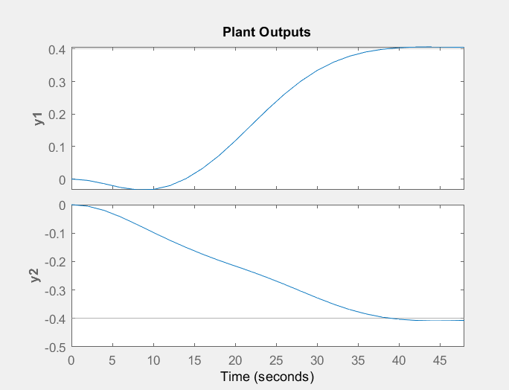

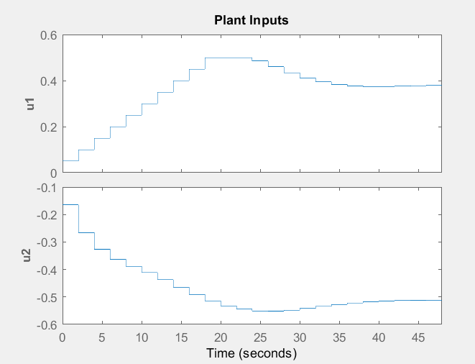

**PART 3: Effect of Q and R:**

**CASE 1**

* Weights: Q=diag([100,1]) R= diag([1,1])
* Constraints: −0.5 ≤ u ≤0 .5, |Δu| ≤ 0.05

Code:

%Setting up the model

G11=tf(1.7,[60.48 15.6 1]);

G12=tf(.5,[19.36 7.04 1]);

G21=tf(.3,[10.89 4.62 1]);

G22=tf(1,[36 12 1]);

G=[G11 G12;G21 G22];

model=ss(G);

%Naming and defining the different inputs, outputs and states

model.InputName = {'u1','u2'};

model.OutputName = {'y1','y2'};

model.StateName = {'x1','x2','x3','x4','x5','x6','x7','x8'};

model.InputGroup.MV = 2;

model.OutputGroup.MO = 2;

old_status = mpcverbosity('off');

%Setting up parameters of mpc

Ts=2;

p=12;

m=4;

%Setting up Constraints

MV=struct('Min',-.5,'Max',.5,'RateMin',-.05,'RateMax',.05);

%Setting up Weights

W=struct('MVRate',[1 1],'OV',[100 1]);

%Setting up the MPC

MPCobj=mpc(model,Ts,p,m,W,MV);

T = 25;

sp = [.4,-.4];

%Running the MPC

sim(MPCobj,T,sp)

* Output:

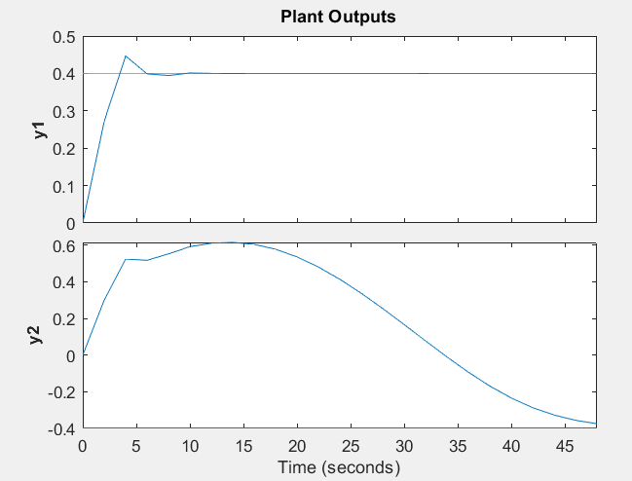

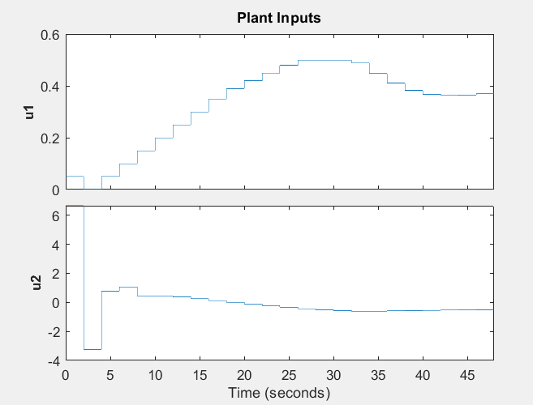

**CASE 2**

* Weights: Q=diag([100,100]) R= diag([1,1])
* Constraints: −0.5 ≤ u ≤0 .5, |Δu| ≤ 0.05

Code:

%Setting up the model

G11=tf(1.7,[60.48 15.6 1]);

G12=tf(.5,[19.36 7.04 1]);

G21=tf(.3,[10.89 4.62 1]);

G22=tf(1,[36 12 1]);

G=[G11 G12;G21 G22];

model=ss(G);

%Naming and defining the different inputs, outputs and states

model.InputName = {'u1','u2'};

model.OutputName = {'y1','y2'};

model.StateName = {'x1','x2','x3','x4','x5','x6','x7','x8'};

model.InputGroup.MV = 2;

model.OutputGroup.MO = 2;

old_status = mpcverbosity('off');

%Setting up parameters of mpc

Ts=2;

p=12;

m=4;

%Setting up Constraints

MV=struct('Min',-.5,'Max',.5,'RateMin',-.05,'RateMax',.05);

%Setting up Weights

W=struct('MVRate',[1 1],'OV',[100 100]);

%Setting up the MPC

MPCobj=mpc(model,Ts,p,m,W,MV);

T = 25;

sp = [.4,-.4];

%Running the MPC

sim(MPCobj,T,sp)

* Output:

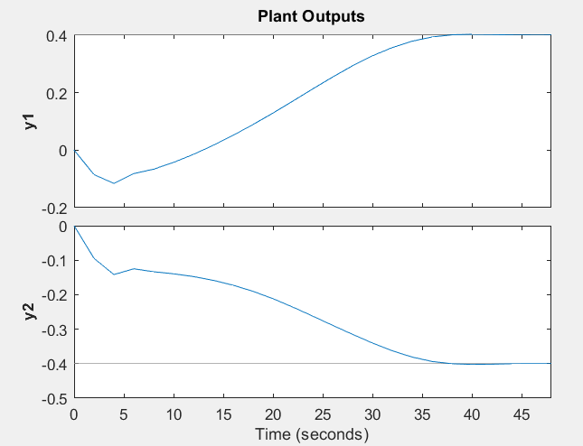

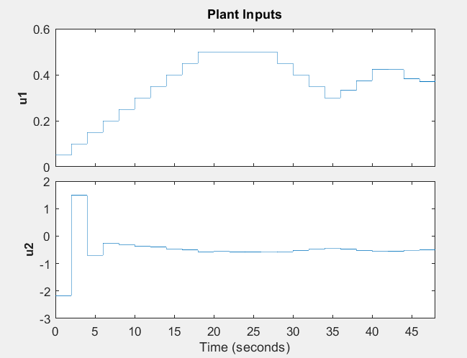

**CASE 3**

* Weights: Q=diag([.01,.01]) R= diag([1,1])
* Constraints: −0.5 ≤ u ≤0 .5, |Δu| ≤ 0.05

Code:

%Setting up the model

G11=tf(1.7,[60.48 15.6 1]);

G12=tf(.5,[19.36 7.04 1]);

G21=tf(.3,[10.89 4.62 1]);

G22=tf(1,[36 12 1]);

G=[G11 G12;G21 G22];

model=ss(G);

%Naming and defining the different inputs, outputs and states

model.InputName = {'u1','u2'};

model.OutputName = {'y1','y2'};

model.StateName = {'x1','x2','x3','x4','x5','x6','x7','x8'};

model.InputGroup.MV = 2;

model.OutputGroup.MO = 2;

old_status = mpcverbosity('off');

%Setting up parameters of mpc

Ts=2;

p=12;

m=4;

%Setting up Constraints

MV=struct('Min',-.5,'Max',.5,'RateMin',-.05,'RateMax',.05);

%Setting up Weights

W=struct('MVRate',[1 1],'OV',[.01 .01]);

%Setting up the MPC

MPCobj=mpc(model,Ts,p,m,W,MV);

T = 25;

sp = [.4,-.4];

%Running the MPC

sim(MPCobj,T,sp)

* Output:

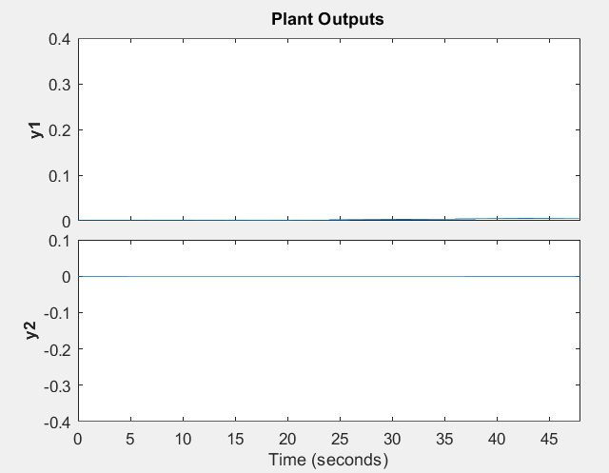

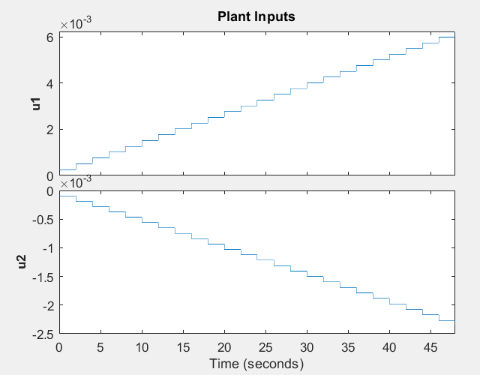

**Inferences:**

* For the unconstrained case both the outputs settle to their respective setpoints with a small overshoot.
* When constraints are implemented for the same weights of the unconstrained case, the first output moves slightly away from the setpoint initially. However both outputs settle to their respective setpoints eventually with no overshoot and a very minimal steady state error .
* When the first output has a higher weight then it reaches the setpoint very quickly with an overshoot. The second output moves away from its setpoint by a large amount initially and then moves almost towards the setpoint but doesn’t settle within the timeframe.
* When the second output has a higher weight then both outputs reach their respective setpoints in an equal amount of time. There is no overshoot or steady state error and the only non ideal observance is that the first output moves slightly away from the setpoint initially. This is the best set of weights among the tested ones.
* When the outputs are weighted lesser than the inputs, the inputs just ascend in steps and the outputs remain almost at zero.